**HP AGM**

**-Agile Manager**

**Agile:**

Agile management, agile process management refers to an iterative, incremental method of managing the design and build activities of engineering, IT and other business areas. Agile is all about timely process.

*Plan -> Build -> Test*

**Project management:**

Planning from starting till the end for successful completion of a project.

**Sprint planning:**

It is a collaborative effort involving a Scrum master, Product owner and Entire Agile team.

**Scrum master -**

* He is the one who facilitates the meeting.
* He is responsible for ensuring scrum is understood and enacted.
* He do service to product owner, development team and organization in different way.

**Product owner** –

* He is the one who clarifies the details of the product backlog items and their respective acceptance criteria.
* He is responsible for maximizing the value of the product and the work of development team.

**Development team** -

* They define the work and effort necessary to meet their sprint commitment.
* Development team consists of professional who do the work delivery a potentially releasable increment of “Done” product at the end of each sprint. (Only members of the development team create the Increment)

**Scrum:**

Scrum is the process framework that has been used to manage complex product development (not for building product/ it is which you can employ various process and techniques).

**Scrum meeting:**

* In scrum, on each day of a sprint the team holds a daily scrum meeting called scrum meet (same location and at same each day).
* Daily scrum is help in the morning, as it helps set the context for the coming day’s work.

**Project closure:**

Handing over to the operations team, tidying up any loose ends, reviewing the project.

**AGM**

**Defined as:**

Agile project management solution to plan, execute and track Agile projects. You can remove latencies, bolster Agile practices, and foster continuous improvement using SaaS or on-premise deployment.

**Used for:**

* Agile project management
* User story management
* Defect management
* IDE integrations
* Development analytics (ALI-Application Lifecycle Intelligence)

**Advantage:**

* SaaS for instant on service.
* Regular release driven by user feedback.
* Web based, clean, intuitive UI.
* Complements HP ALM/QC.

**Features:**

* Release
* User Story
* Defect Management
* Development Tools Integration
* Team/Resource Management
* Rest APIs
* HP ALM/QC/PPM Synchronizer
* Regular releases driven by user feedback
* Modern, clean, intuitive UI
* SAFeTM Gold Certified.

**Main features:**

* Drag-and-drop interface
* Task and release planning boards
* Real-time feedback on progress
* Advanced development analytics
* Seamless integrations
* IDE integration
* Built-in sprint closure and retrospective capabilities
* Push-button workspace provisioning
* User-friendly
* Instant-on, anytime/anywhere access via SaaS delivery

**Also known as:**

Agile Manager, HP Agile Manager, AGM, HP AGM

**Sample Customers:**

Trizetto, Discount Tire and Siemens

**Key Features**

## Plan

Drag and drop interface that enables easy release and sprint planning, task allocation and [capacity management](http://www8.hp.com/us/en/software-solutions/capacity-planning-server-virtualization-management/index.html) across teams and individuals.

## Collaborate

Task and release planning boards give all team members ready insight into the entire project landscape, workflow, and potential issues or bottlenecks. Seamless integration with [ALM](http://www8.hp.com/us/en/software-solutions/alm-software-development-testing/index.html) and [Quality Center](http://www8.hp.com/us/en/software-solutions/quality-center-quality-management/index.html) using comprehensive Continuous Integration Tools.

## Track

Advanced development analytics aggregate source code and build information to surface meaningful insights into application changes, allowing for precise risk analysis and more informed decisions.

## Alignment

Strategically aligning empowered agile teams with enterprise business objectives.

## Higher Code Quality

Assuring systemic quality of code vital to any business that depends on software.

## Transparency

Helping teams be hyper-productive and highly efficient through fully visible work environments.

**AGM: A day in the life.**

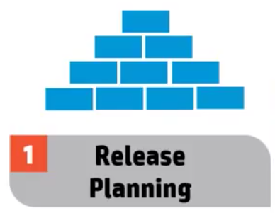

* Structure release
* Define teams
* Manage release backlogs

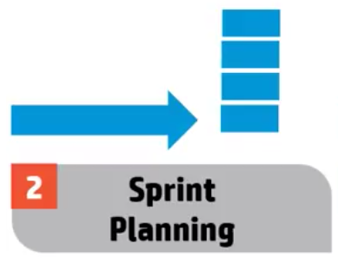

* Plan user stories & defects
* Assign to team
* Manage team capacity

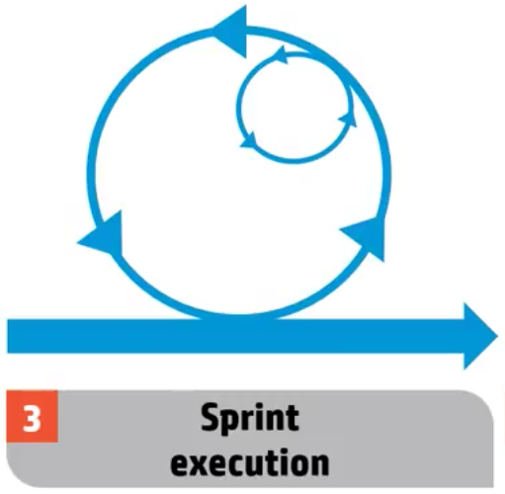

* Allocate tasks
* Implement & update
* Defect management
* Retrospective & close

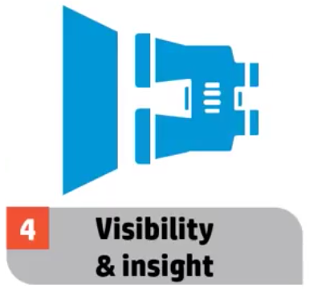

* Development analytics
* Customizable report

**SaaS on instance service:**

* Signup and Login.
  + <https://www.saas.hpe.com/signup>
* Once done launch the service.

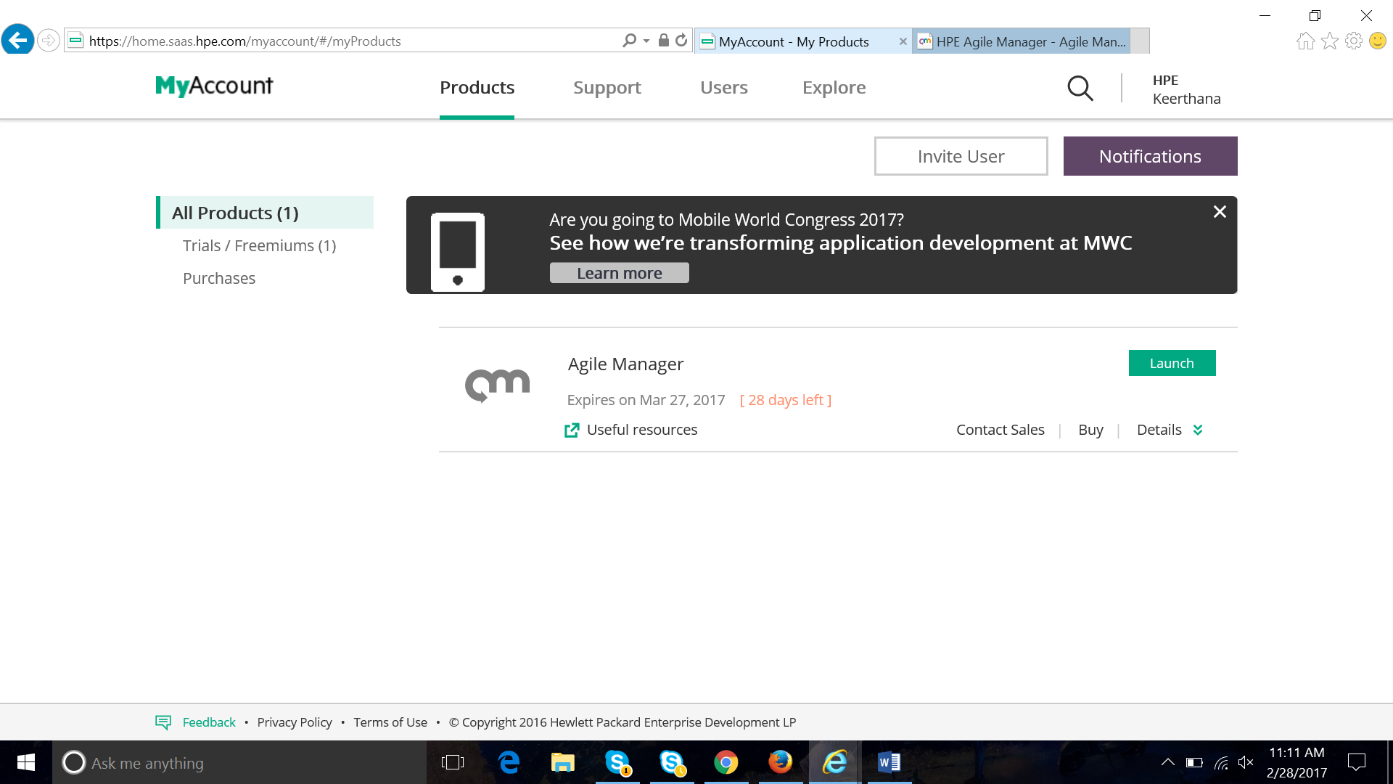

* Can invite user or add user to your service. 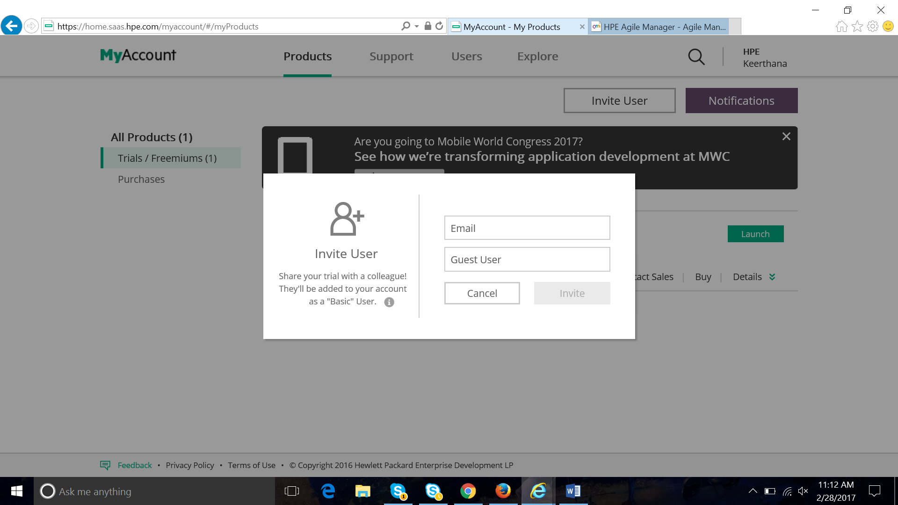

**Login Activity can be tracked:**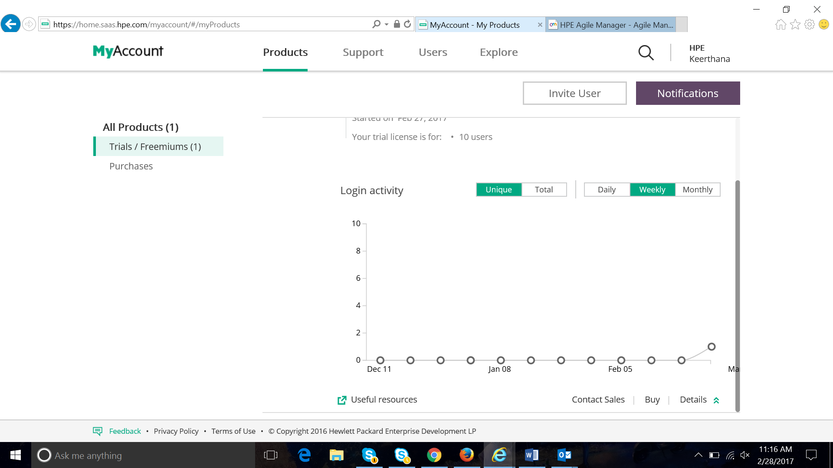

**Help center:**

<http://agmhelp.saas.hp.com/en/Latest/Help/Default.htm#cshid=new_features>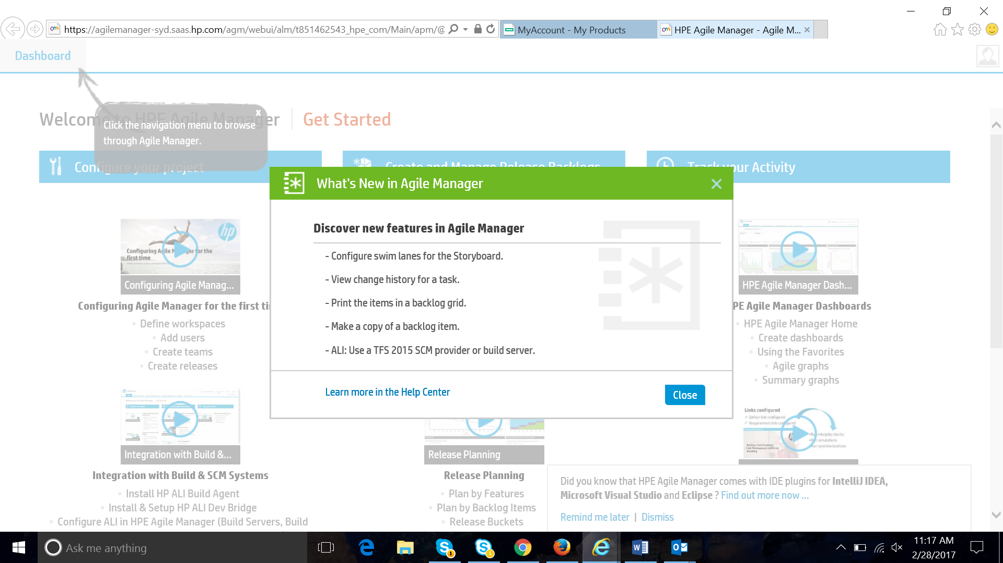

**Start service:**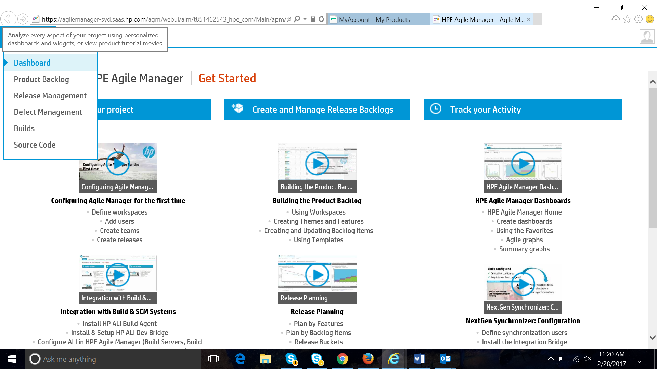

**AGM comes with IntelliJ plugin:**

Did you know that HPE Agile Manager comes with IDE plugins for IntelliJ IDEA, Microsoft Visual Studio and Eclipse? Find out more now...

<http://agmhelp.saas.hp.com/en/Latest/Help/Content/ALI_Content/ALI_dev_plugins.html>

**User roles and permissions:**

**System administrator –** RW to AGM on premise system administration site (Has access to system administration only)

**Site administration –** RW to site configuration page.

Workspace administration – RW to all app pages and functions as well as the workspace configuration.

**Team members –** RW to all app page and functions with some exceptions.

Viewer – Only Read access.

**Integration administration –** RW access to integration and synchronizer configuration page.

**Integration Bridge –** Manage communication between AGM and next gen synchronization Integration Bridge.

**Configuration:**

To go to configuration file select  on the right top

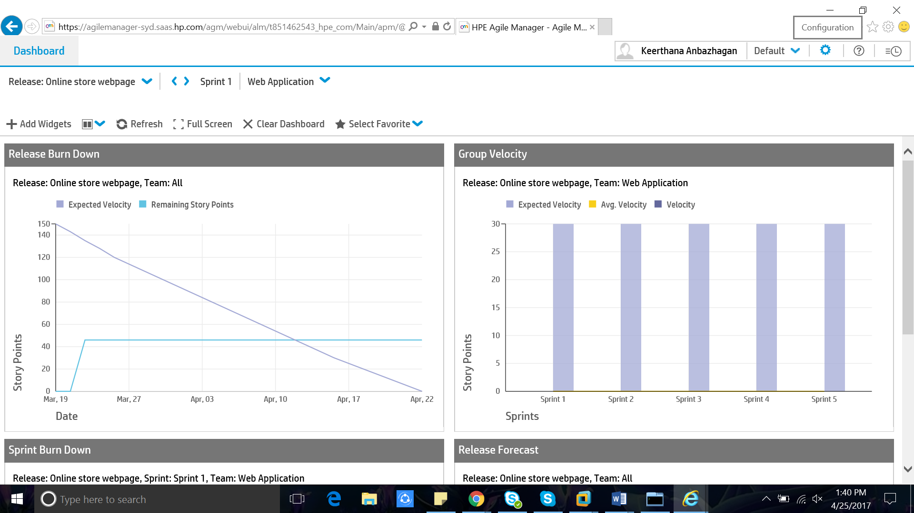

There are 3 type of configurations

* Site
* Integration
* Workspace

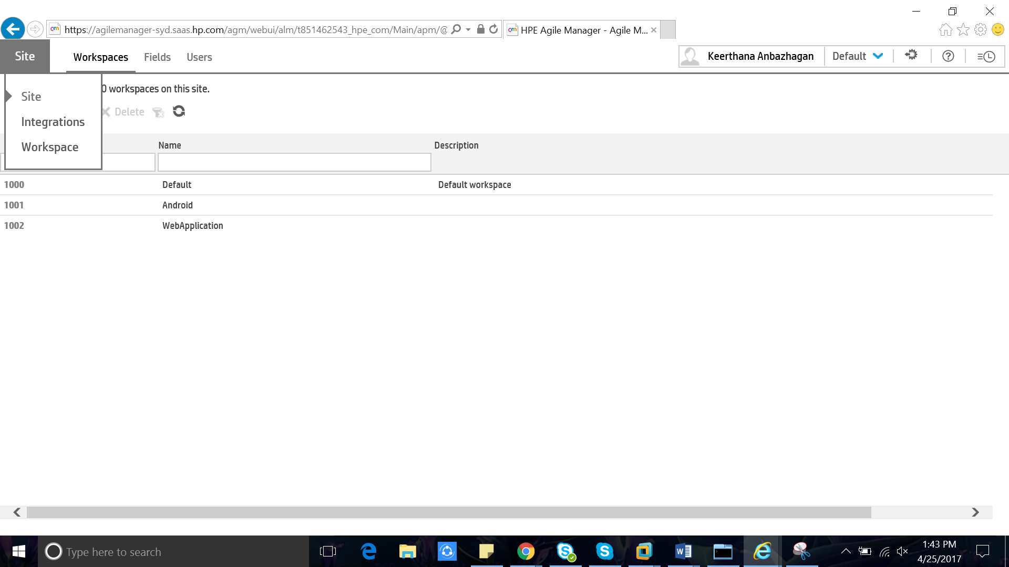

To add new workspace + Add workspace

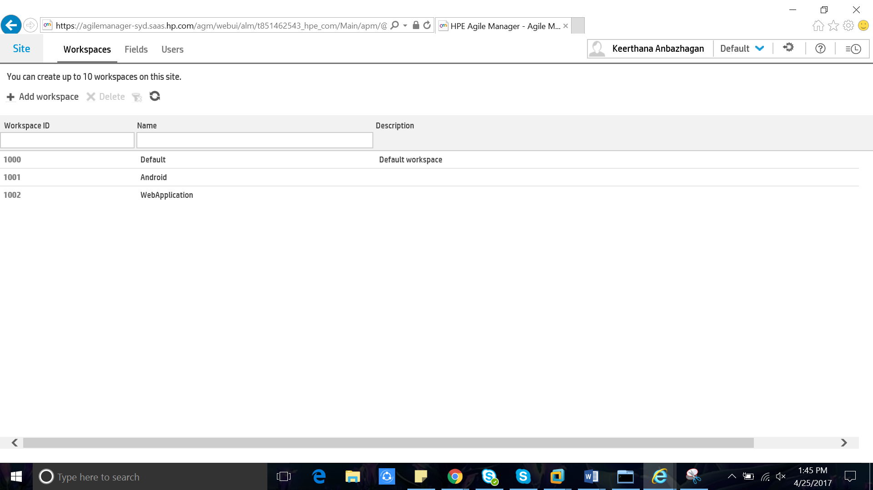

Add Custom field –> + Add Field

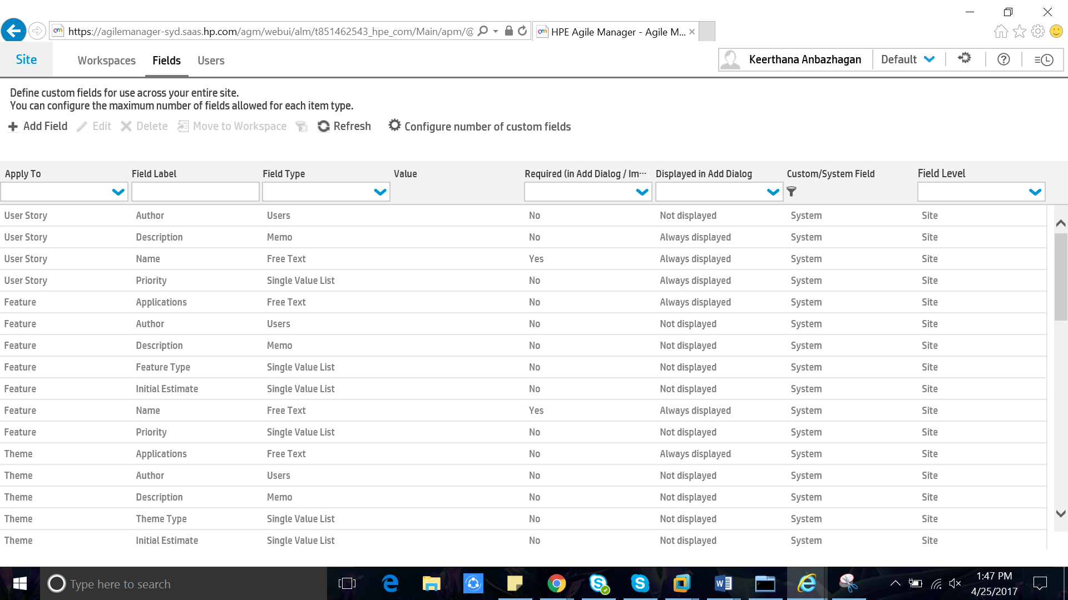

**To add users to Site:**

Site –> Users + Add New user

**You can**

* Add New User
* Include Users
* Remove Users
* Activate Users
* Deactivate Users
* Assign to Roles
* Set License Type
* Set SCM User Mapping
* Assign to Workspace

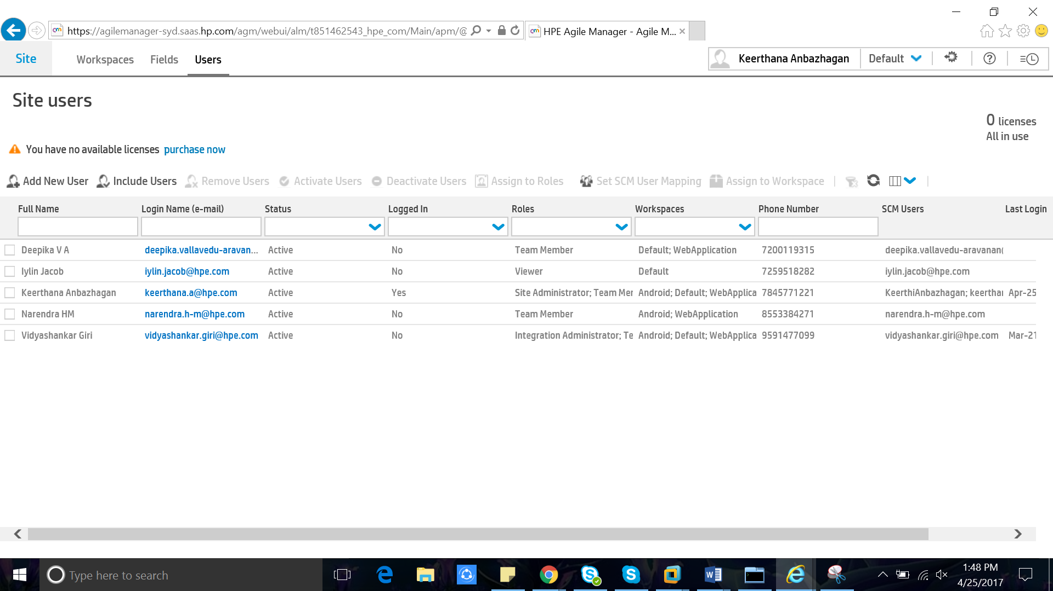

**Integrations -> API**

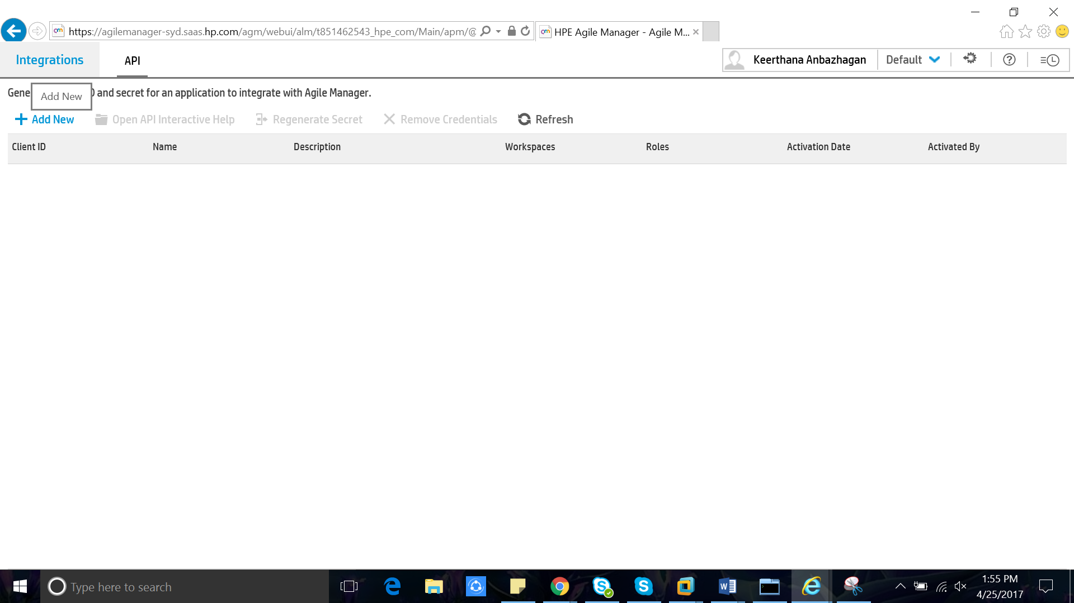

**REST API Client:**

**API enhancements**  
- Retrieve history for themes, features, backlog items, and tasks.  
- Additional data included in theme and feature entities.  
- New **custom_fields** unique resource helps match custom field names to their API names.

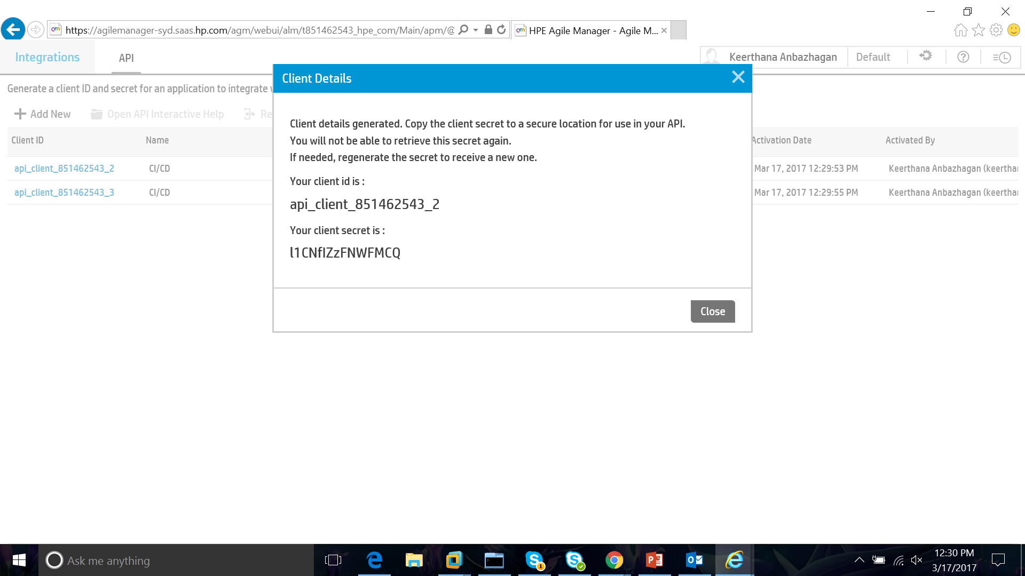

**Workspace -> Settings:**

* Used to change workspace default settings like capacity, story points, task, etc.
* Story: Large body of work broken into smaller unit of work according to end user requirements and feedback.
* Story points: The complexity/effort needed for user stories are measured in the story points. It is used to calculate how many user stories a team can take in an iteration.
* Time Limit – How long it takes to work on items at different stages.

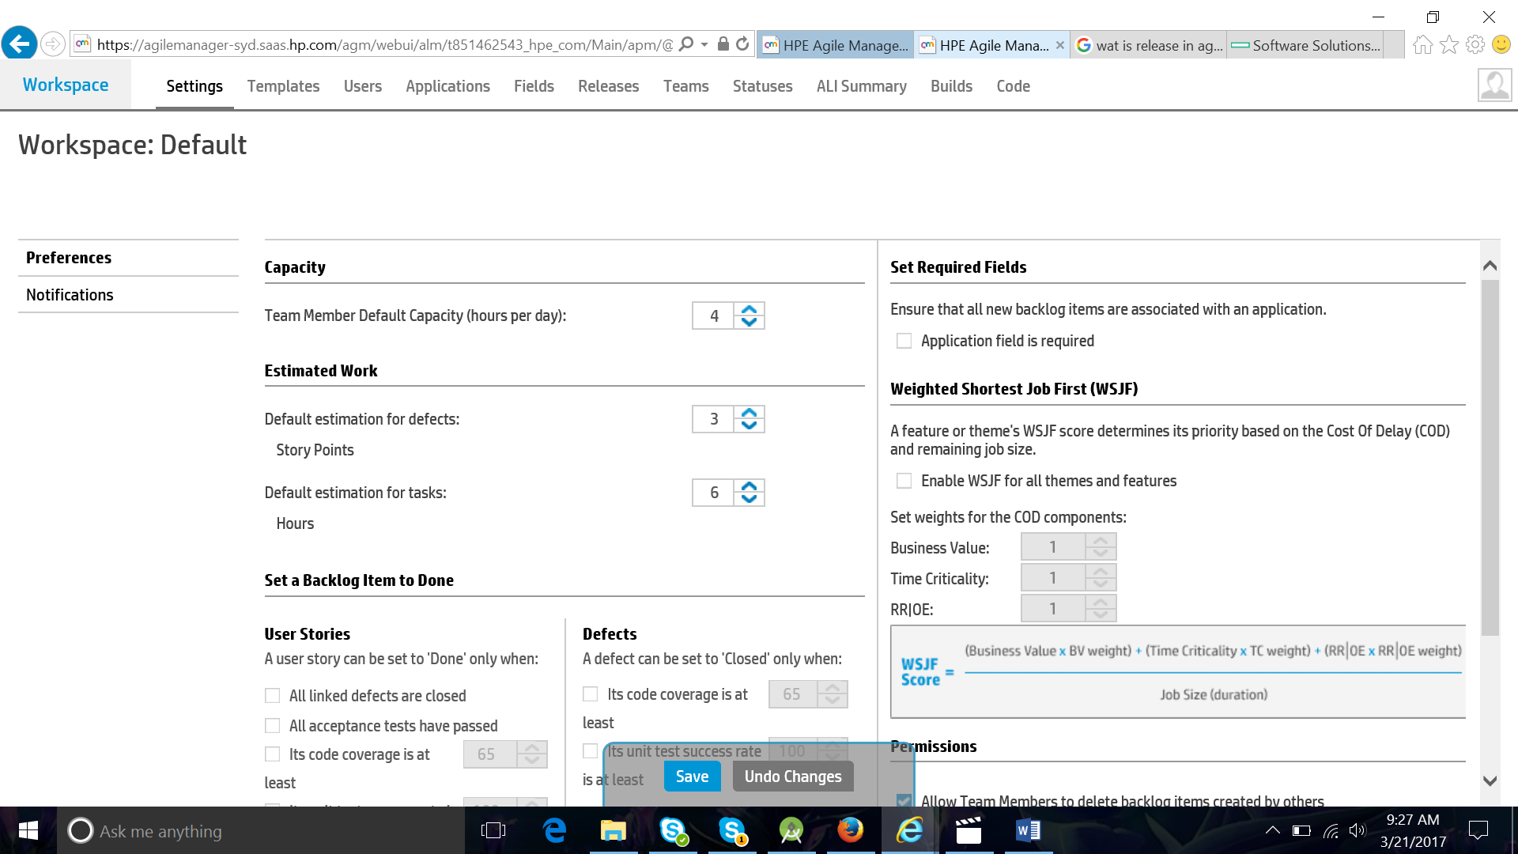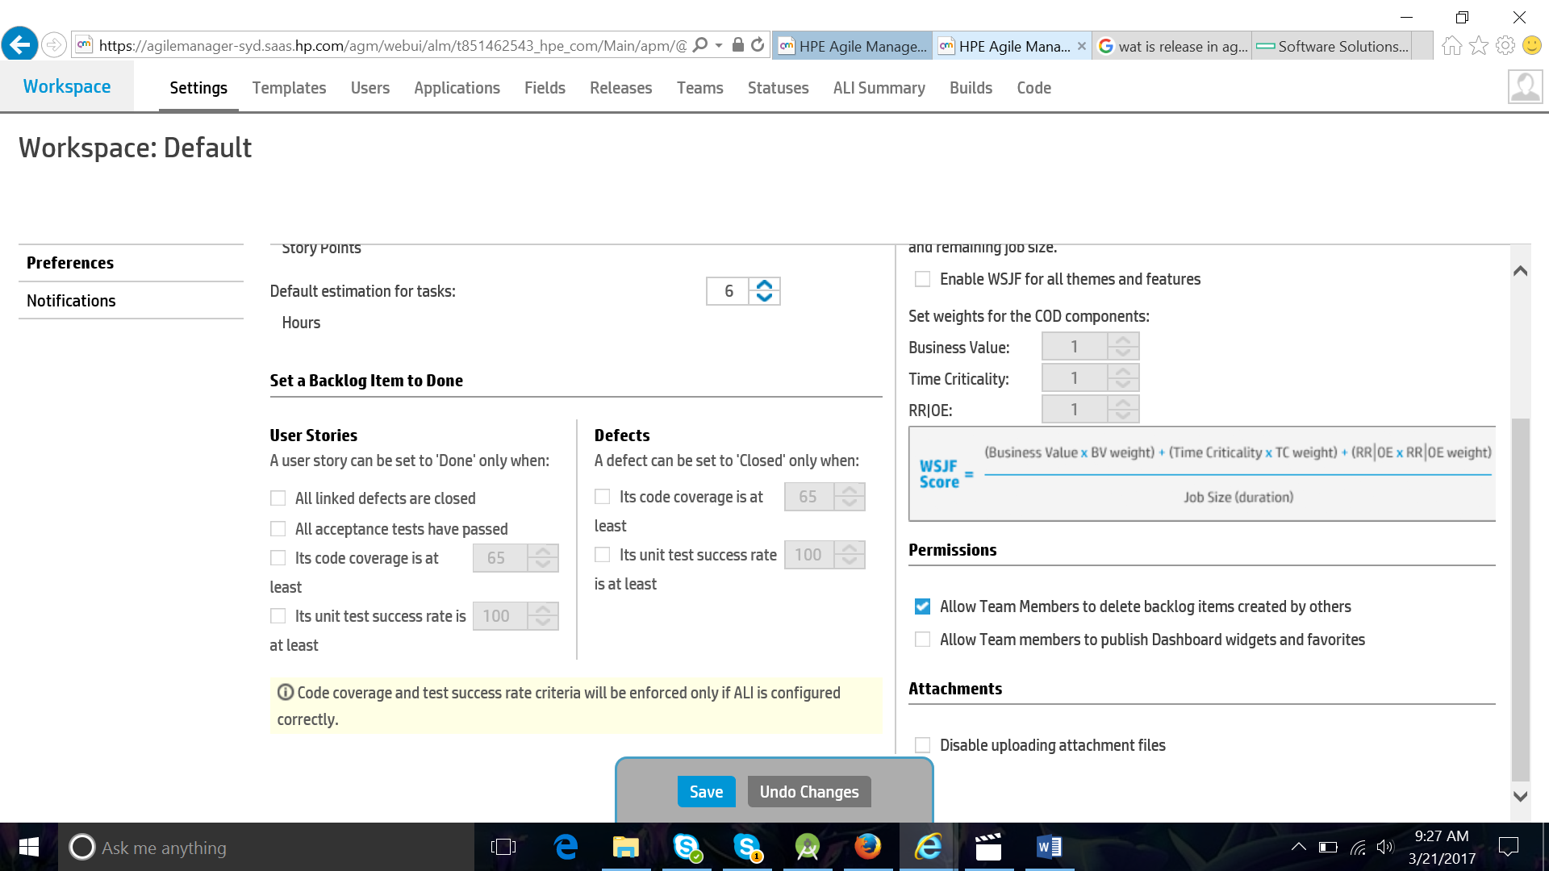

**Create New Application:**

+ Add Application

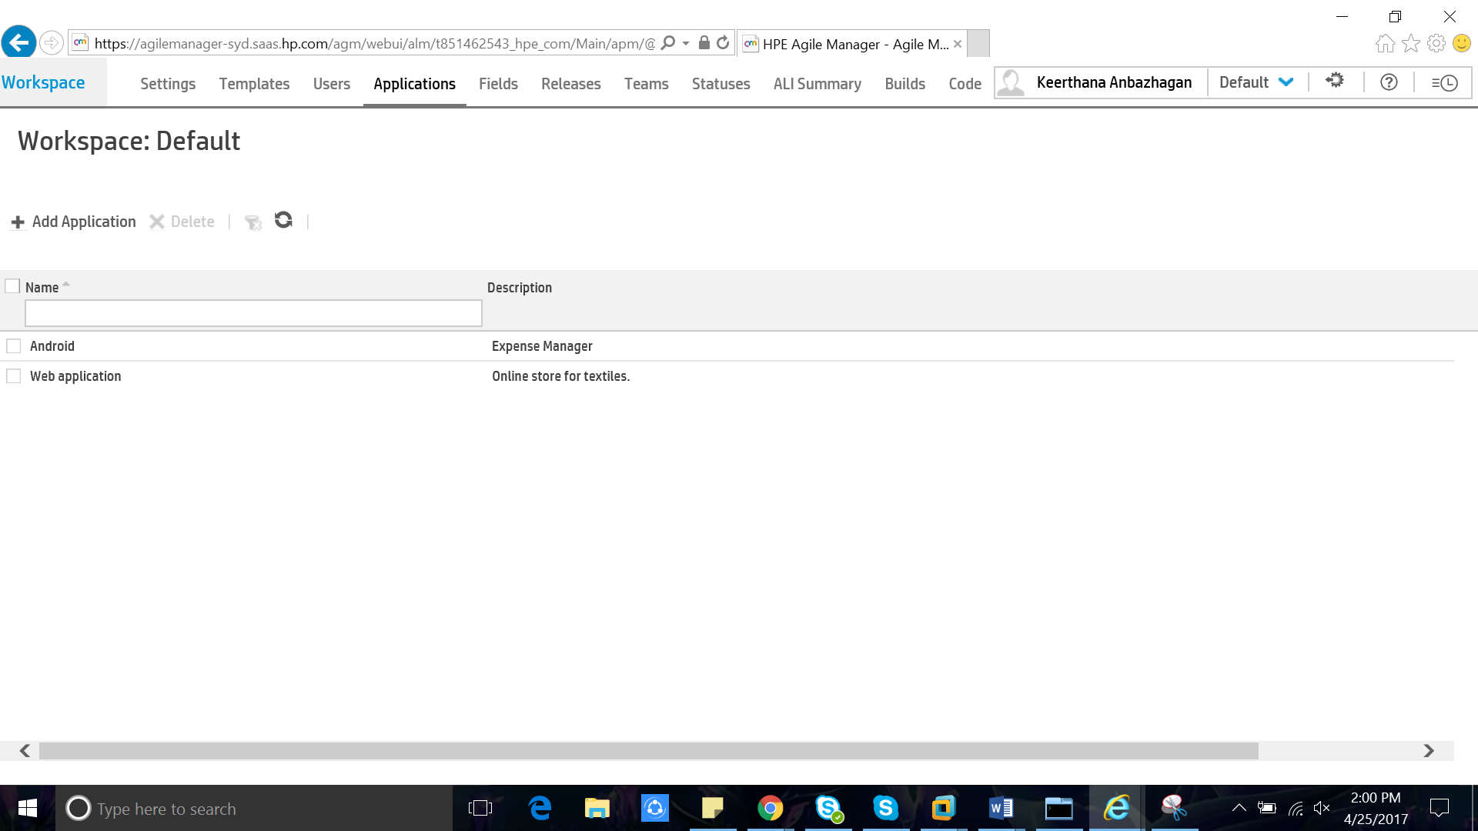

**Create New Release:**

* Whenever a project is started a new release is create to manage it.
  + Here I have created a sample project called Android to make an Expense manager application for android mobiles.
* Then we need to mention the release time frame of the project
* Then sprint duration and its unit is mentioned.
  + **Sprint:** 
    - A **Sprint** (or iteration) is the basic unit of development in **Scrum**.
    - The **Sprint** is a set period of time during which specific work has to be completed and made ready for review.
    - The duration is fixed in advance for each **Sprint** and is normally between one week and one month, with two weeks being the most common.
* There are 2 modes:
  + **Scrum mode –** Strictly works under sprint.
  + **Kanban mode –** continuously works throughout the release.
* Then save to create a release.

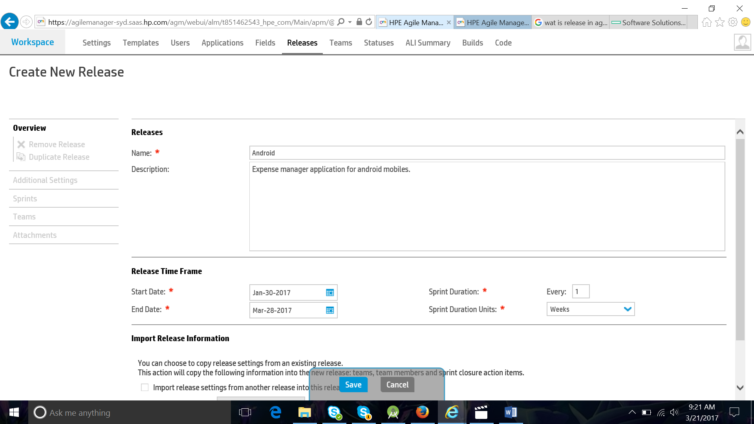

**Create New Team:**

+ Add Team

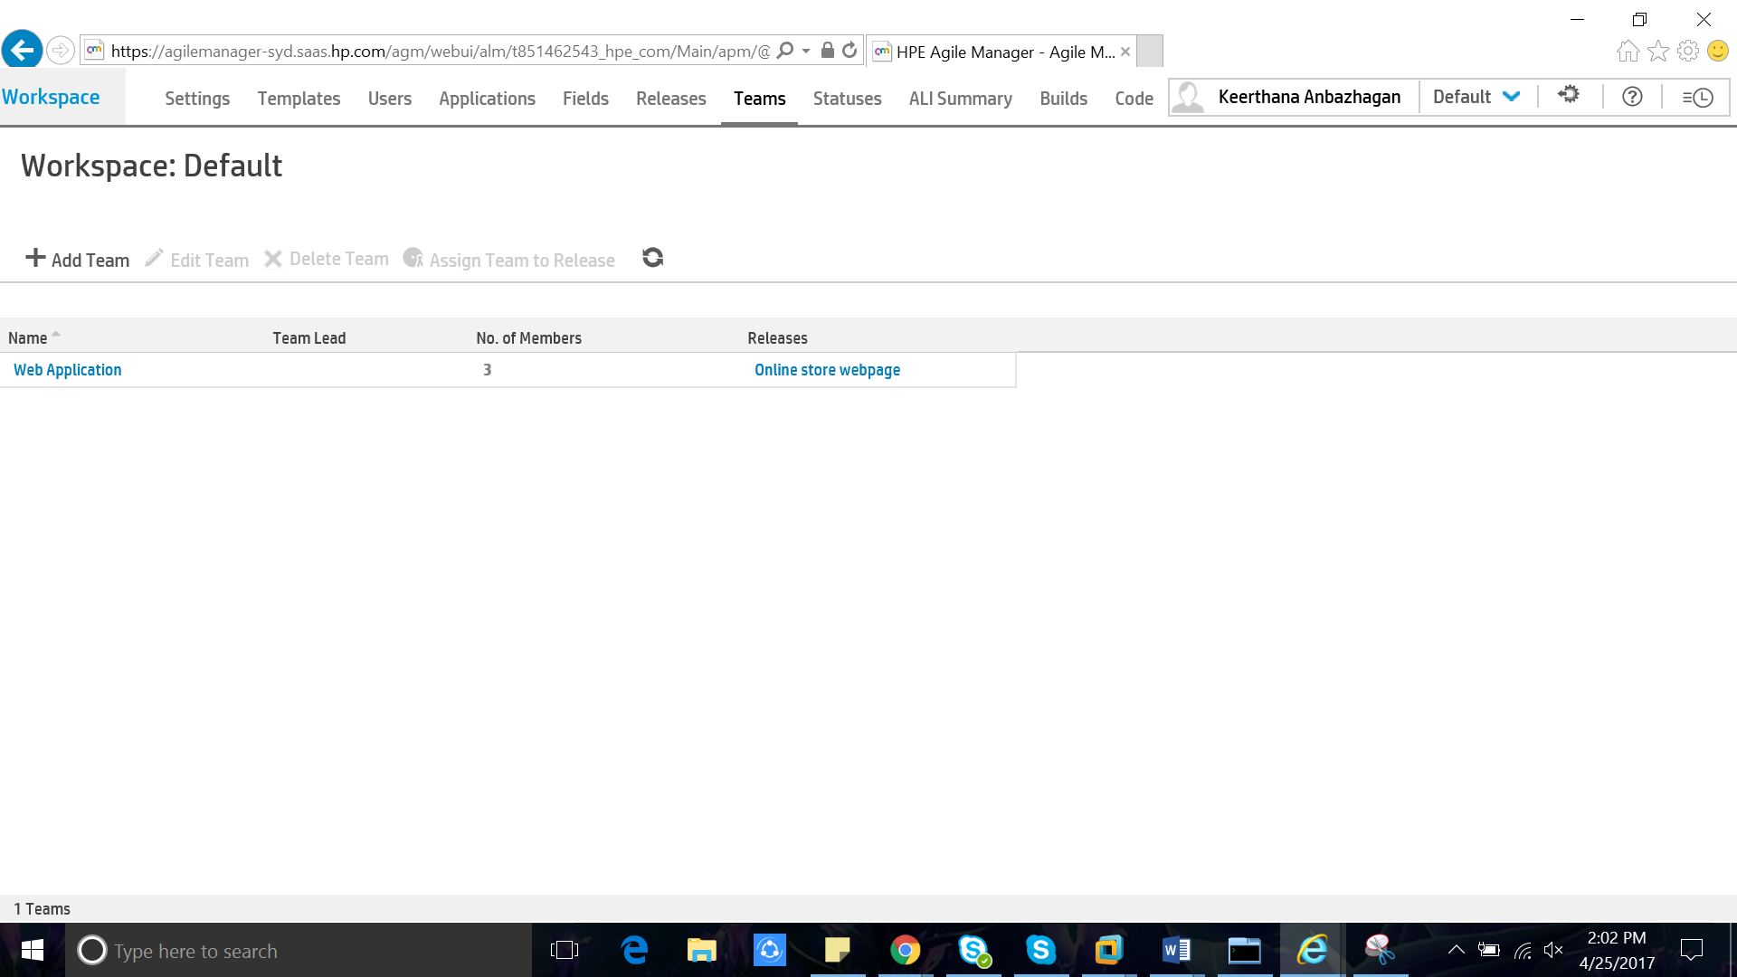

**Login Activity Graph:**

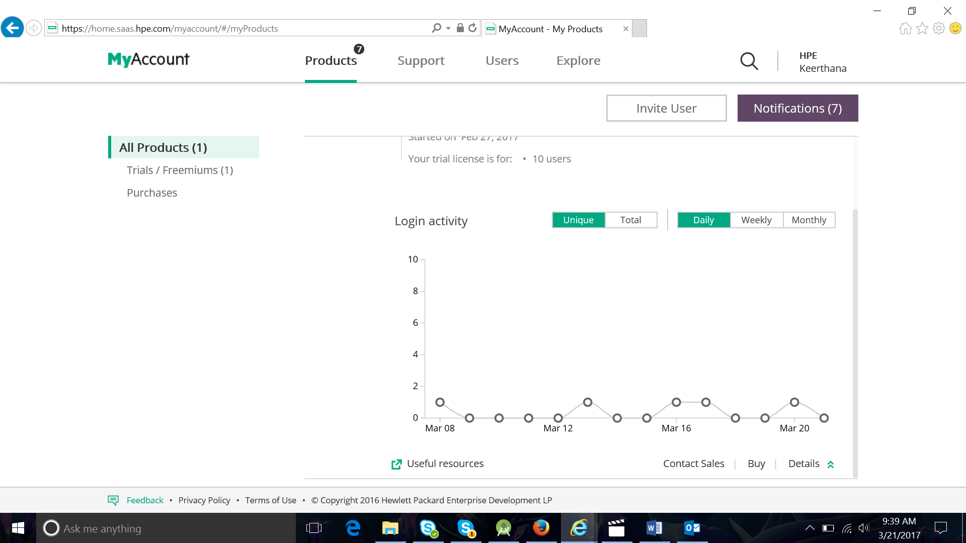

**Dashboard:**

A graphical summary of various piece of important information, typically used to give an overview of a project.

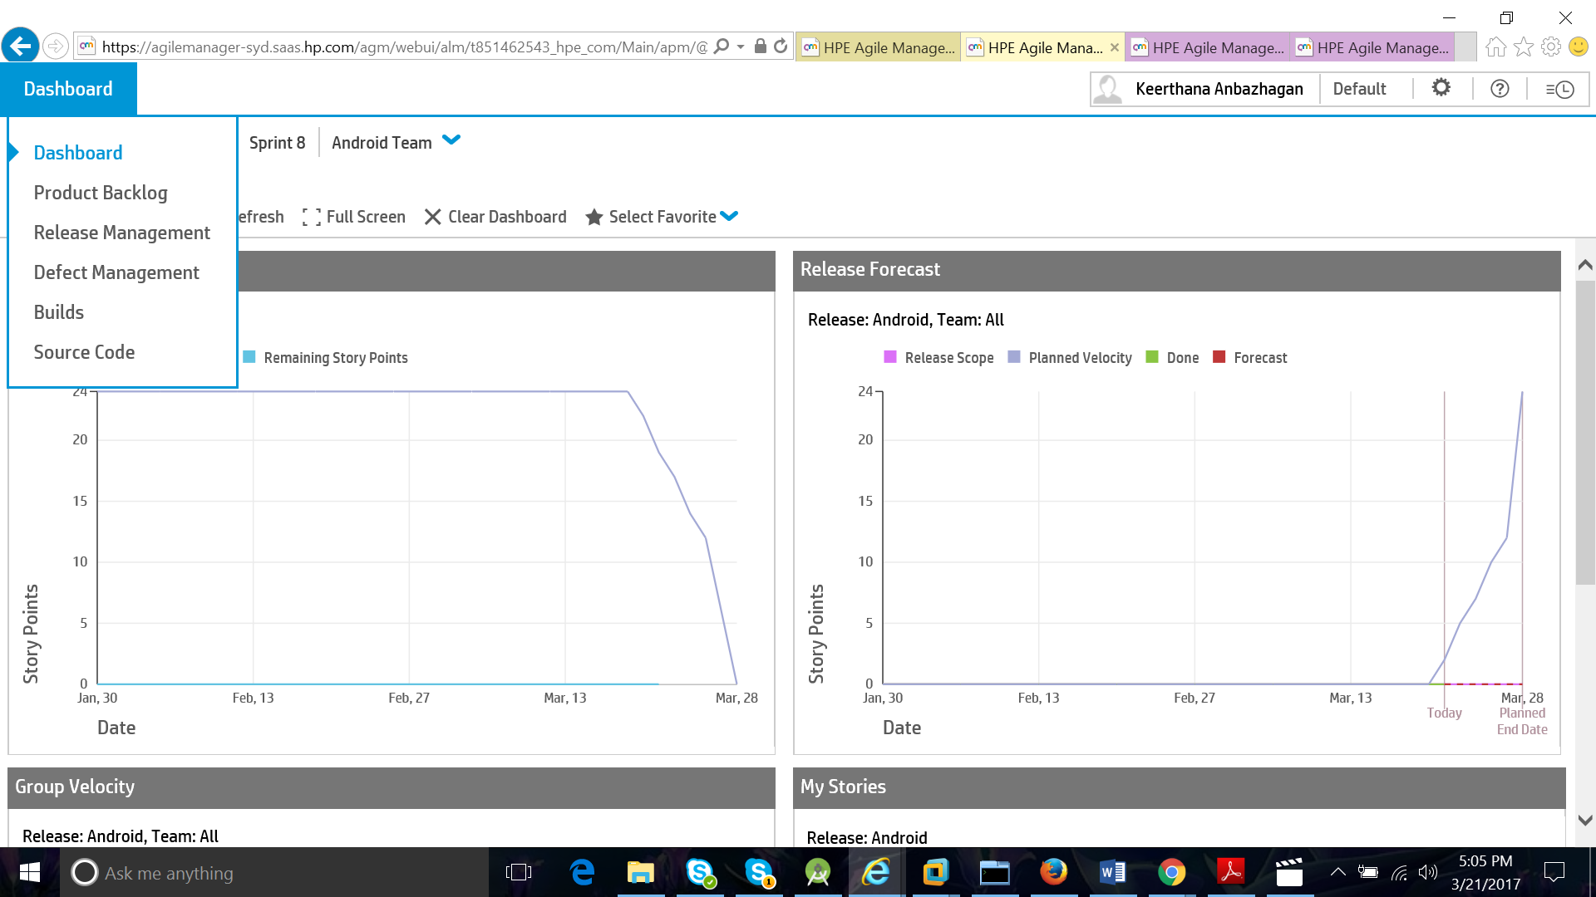

**Backlog:**

List of technical tasks which the team maintains and which the team maintains and which at a given moment are known to be necessary and sufficient to complete a project or a release.

**Product Backlog:**

* Product owner is the sole person responsible for managing the product backlog.
* Product backlog is an ordered list of everything that might be needed in the product.
* Product backlog is never completed (It is dynamic).

Here product backlog has a couple of different area.

**Themes –** High

**Features –** Next level

**Backlog –** user stories (connected to features)

**Themes:**

It is the large body of work/a large user story that can be broken into a number of smaller stories. It takes several sprints to complete a Theme.

For a project there might be many themes like requirements, development, integration, testing, etc.

Themes are created under release and each theme must be assigned with number of story points to complete it.

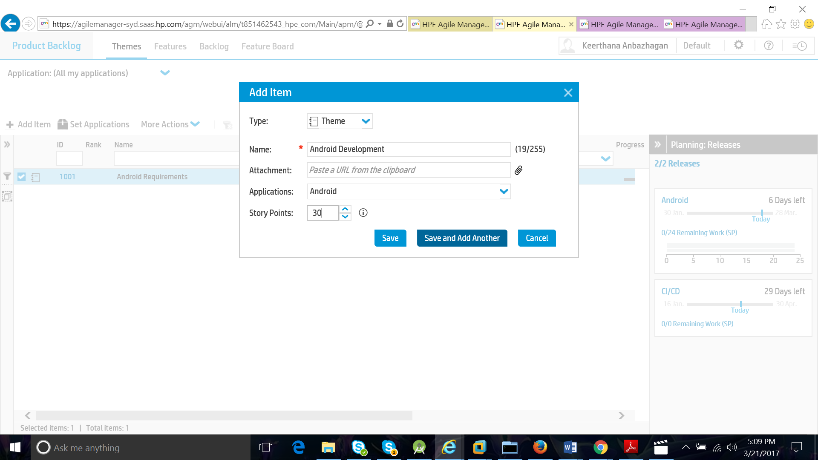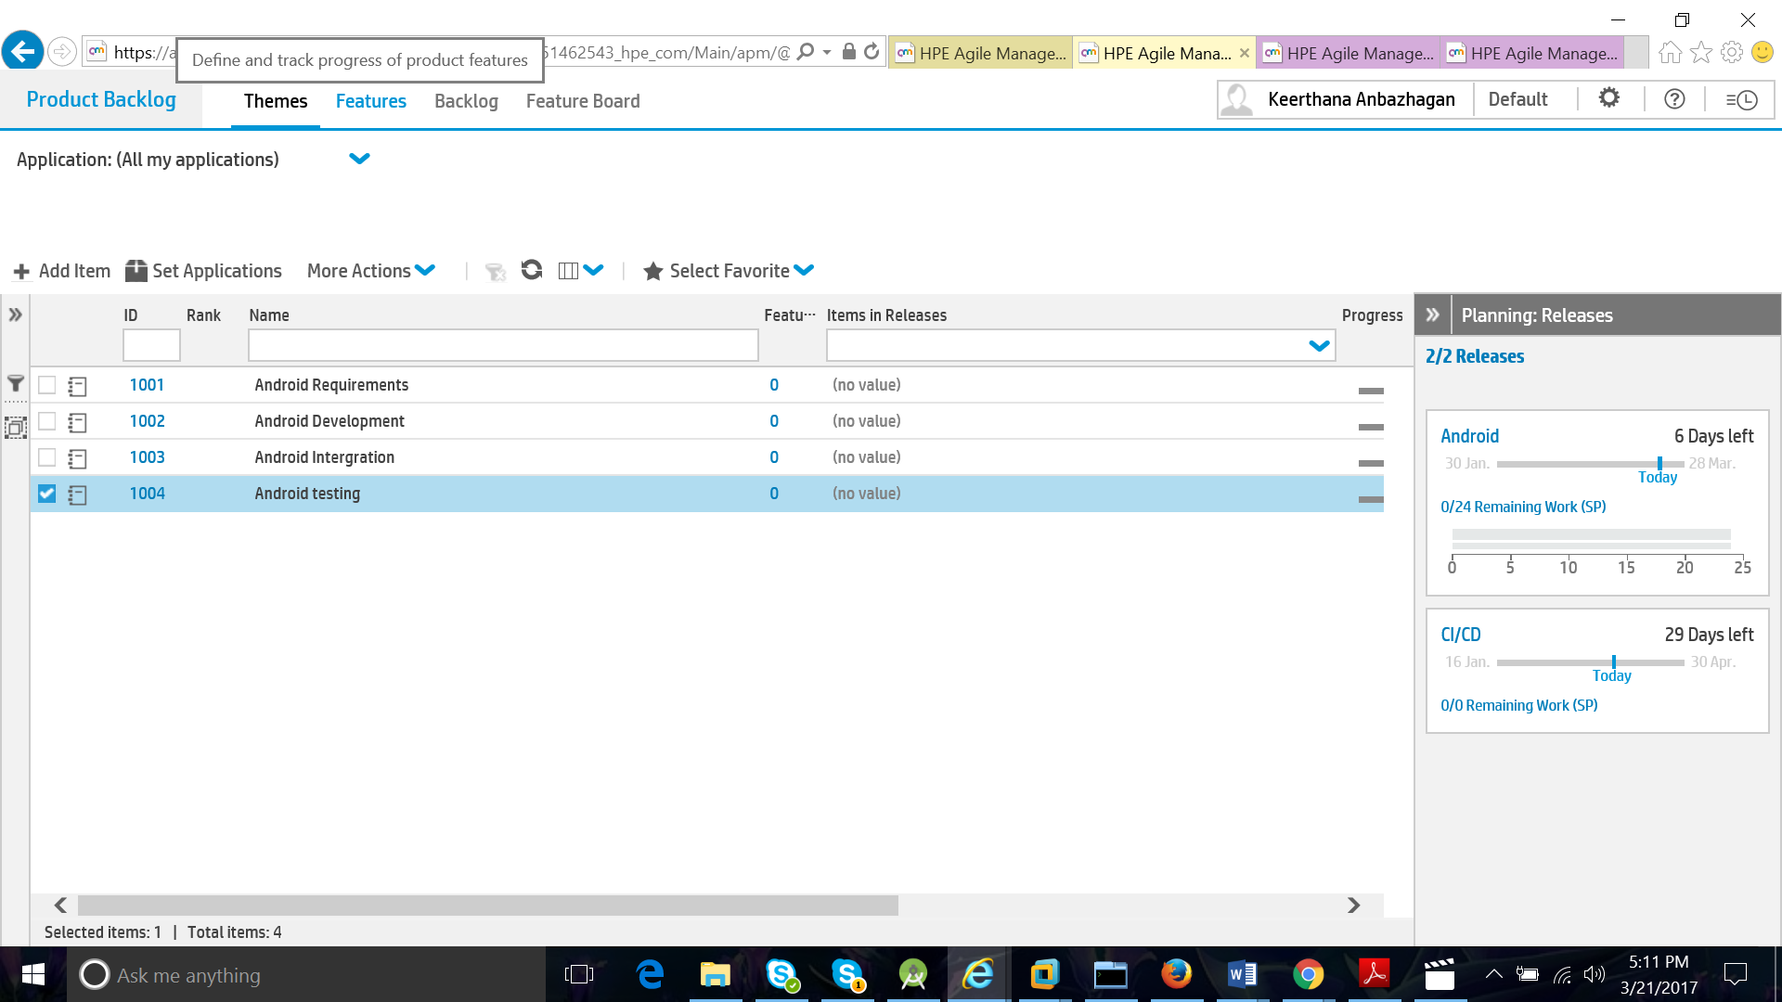

**Features:**

Features are the smaller unit of work/task sub divided from themes.

This features can be further divided into task and sub tasks and can be assigned to the team members.

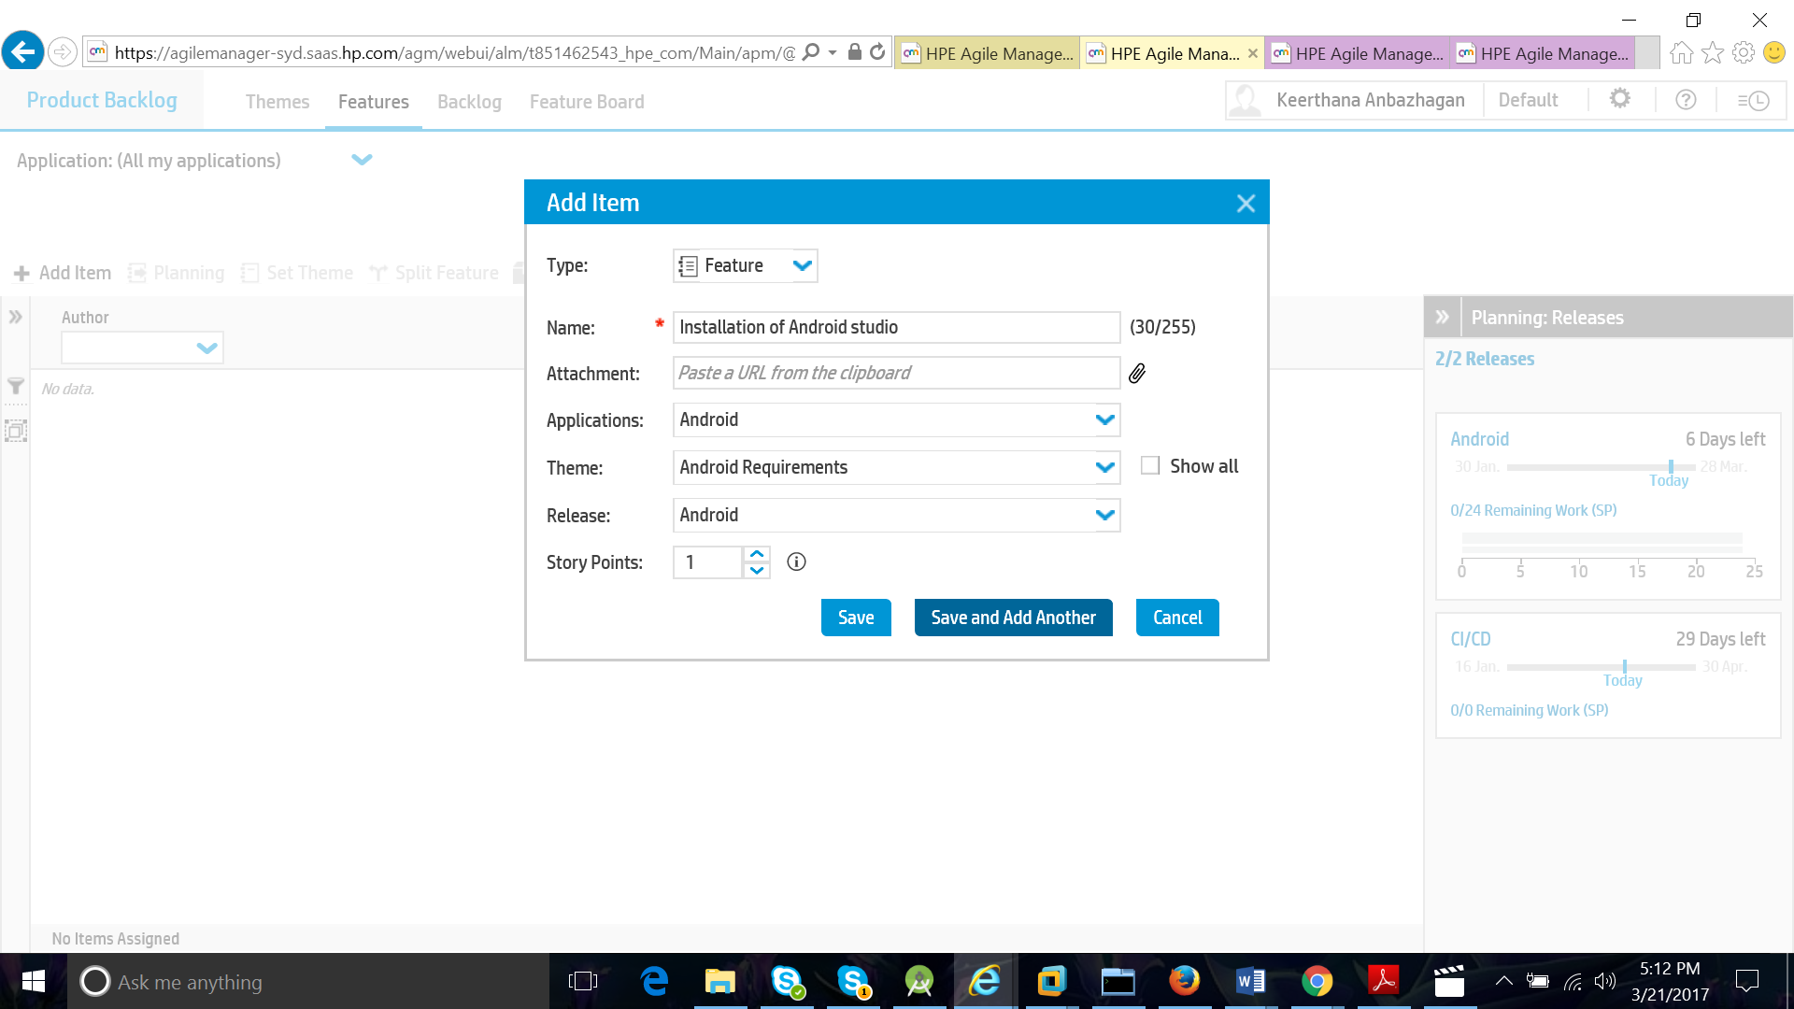

**User stories:**

User stories are the requirements and direct feedbacks from the end user.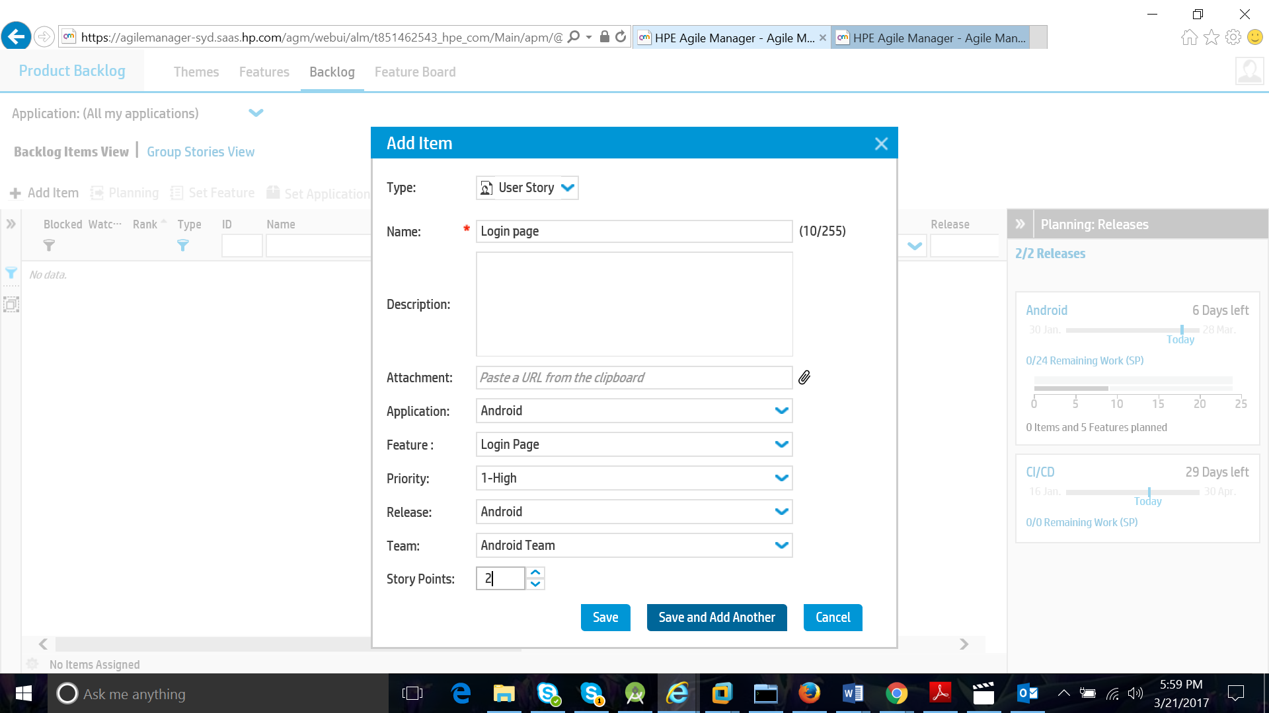

**Feature board:**

Manages the flow of features through their development stages and across release with a configurable and interactive feature board.

There are 7 status column:

**New –** Features initial state.

**Defined –** Priority has been set according to cost of delay, business value, etc.

**Scoped -** Feature is planned for a release but work on the feature is not yet started.

**In progress –** The features is broken into user stories and assigned to a release.

**Done –** All features backlog items are completed.

**Accepted –** The product owner or manager is satisfied with the features implementations.

**Descoped –** The feature was removed from release plan.

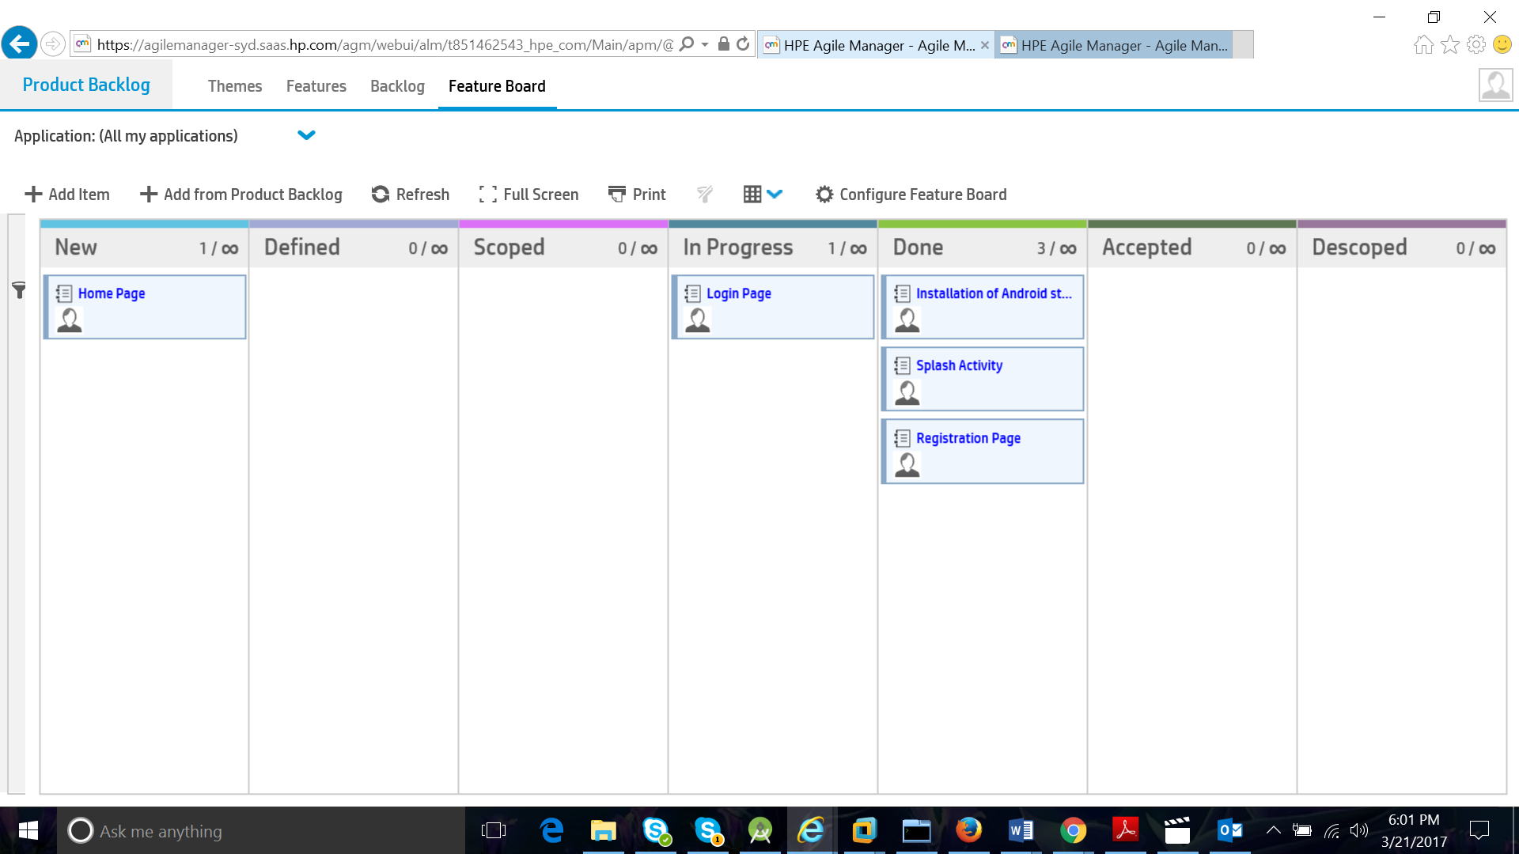

**Release management:**

Build & manage a release backlog.

Tracks the release progress and analyse its quality in release management area of AGM.

**Key features of Release management:**

* Plan a release
* Plan sprint backlogs
* Tracks the progress of backlog
* Import backlog items
* Watch backlog item
* Add user stories to the release backlog.

**Release backlogs:**

Manage release backlogs and assign item to sprint and teams.

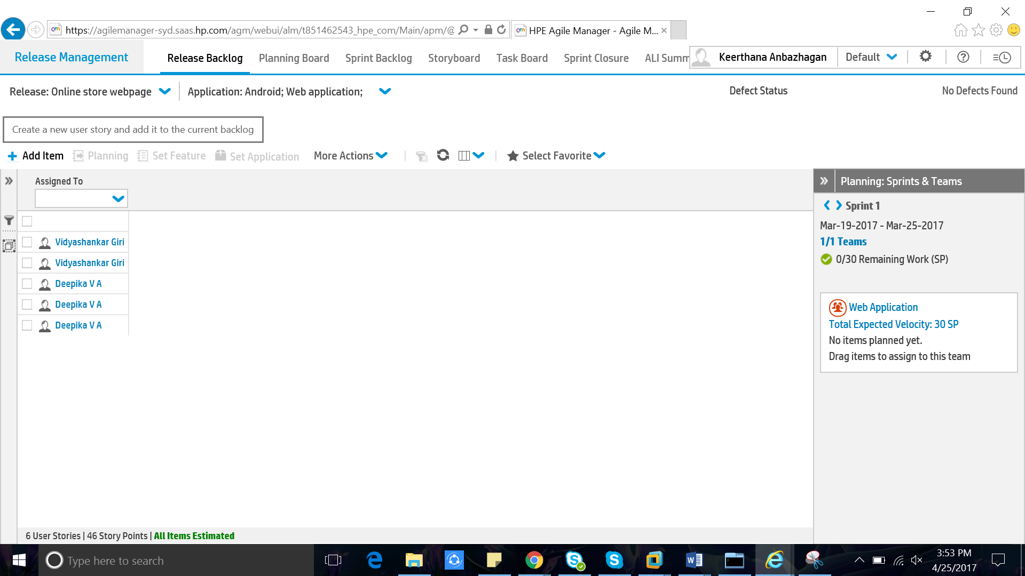

**Velocity:**

Calculated by reviewing work the team successfully completed during previous sprints.

Result => number of story * number of story points in each stories.

Team velocity => Result story point per sprint

For example:

In a 1 week sprint 10 stories are completed

Each story has 3 story points

Then 30 story points per sprint is the velocity.

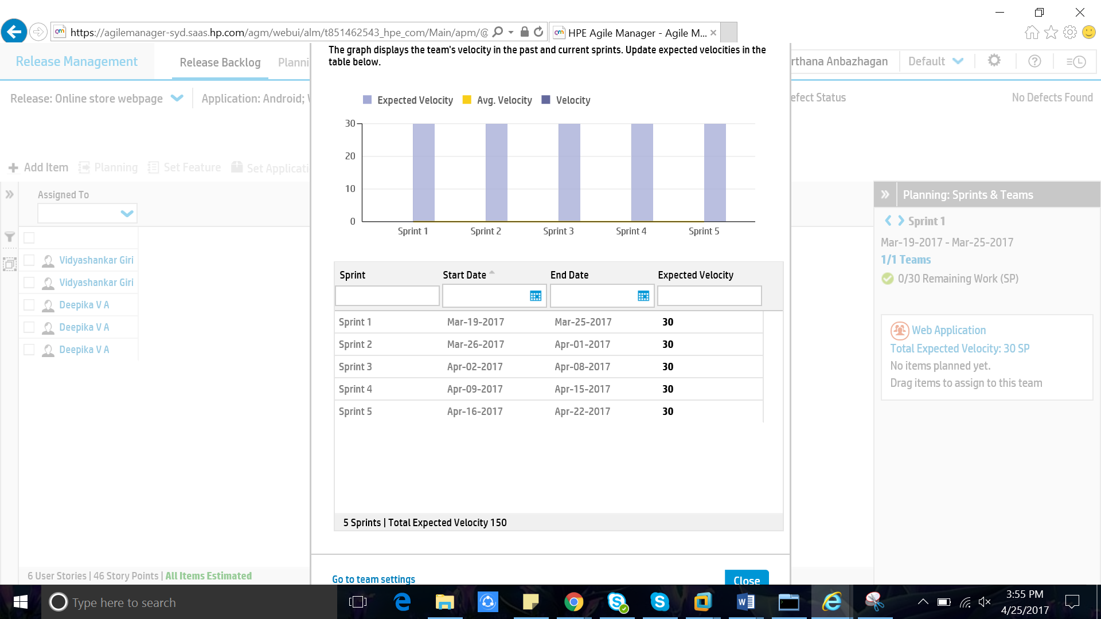

**Planning board:**

In planning board we can see the plans of release management.

Select which release you need to plan.

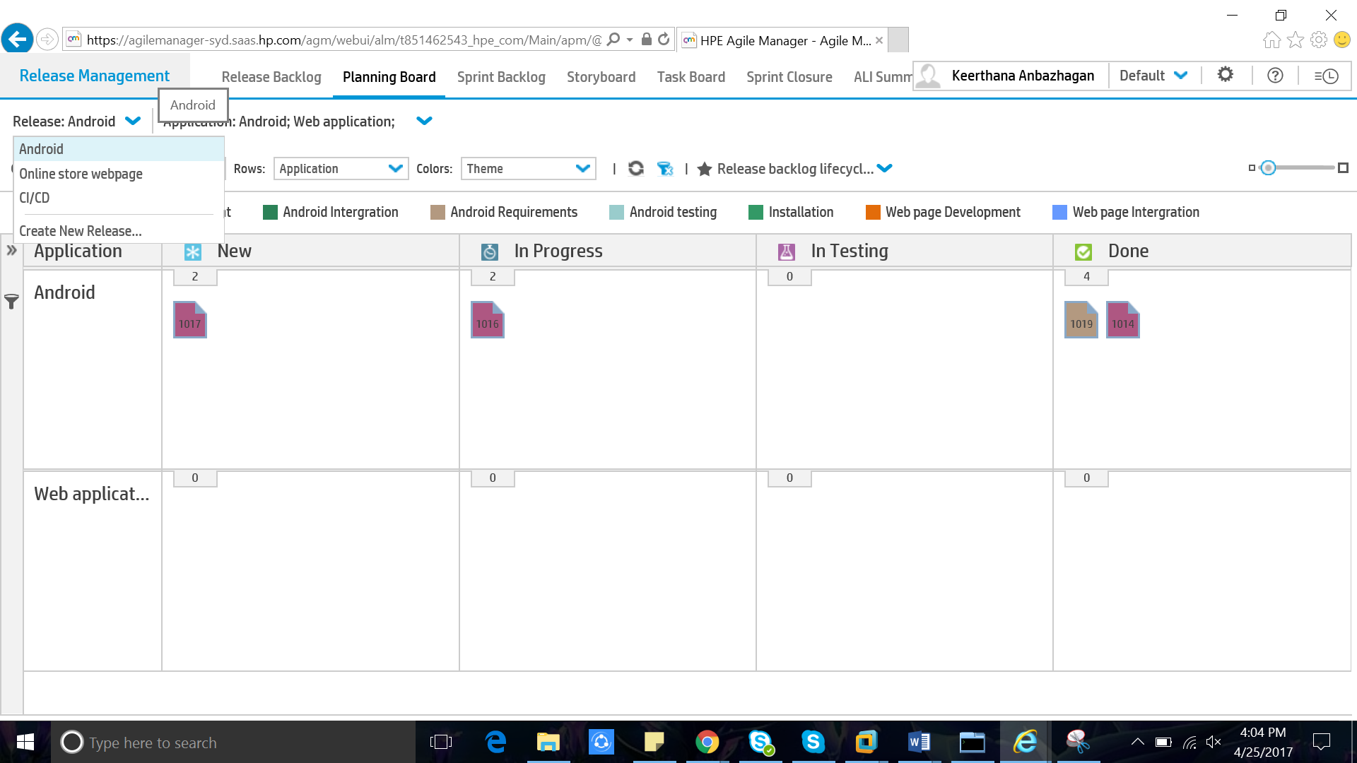

Select rows and columns to be displayed

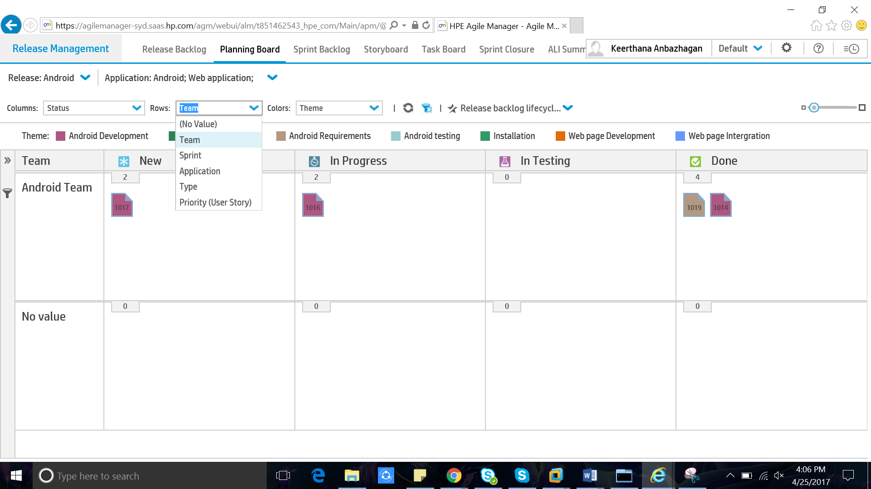

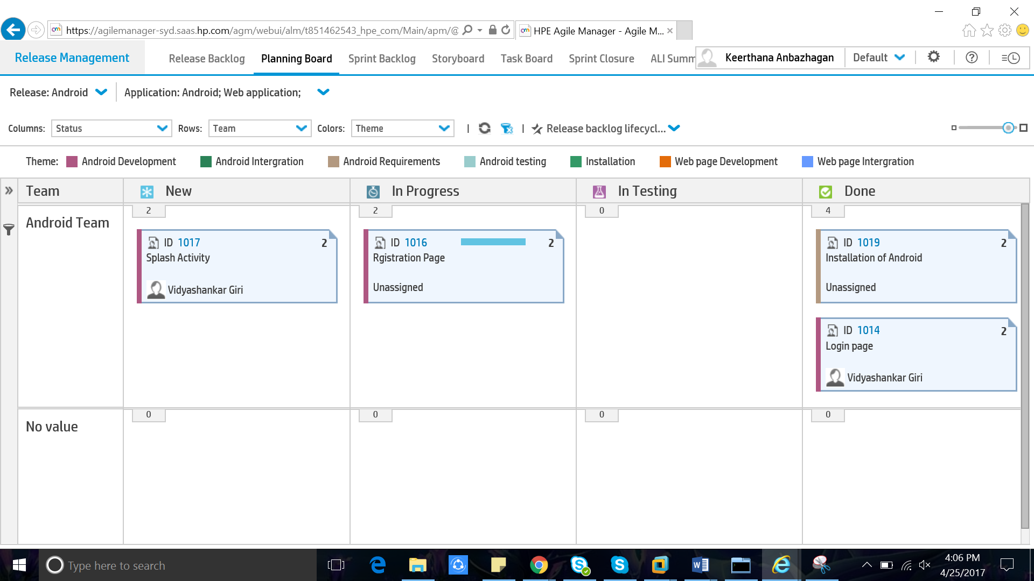

**Sprint Backlog:**

* It is the set of product backlog items selected for the sprint.
* This is forecast by the development team.
* This makes visible all of the work that the development team identified as necessary to meet the sprint goal.

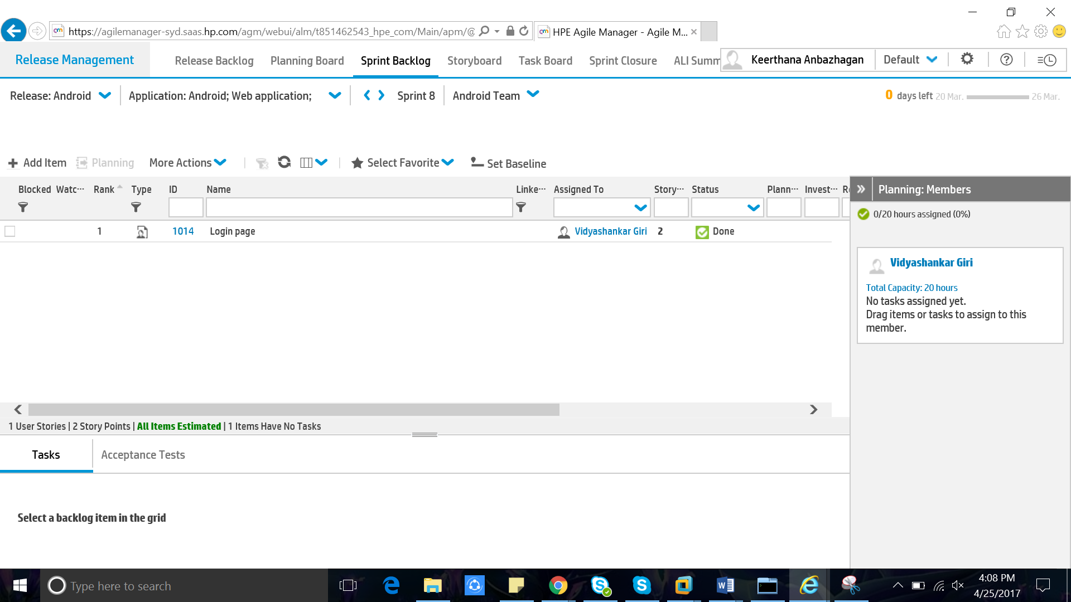

**Story Board:**

Tracks the flow of backlog items through their development life cycle. Move items through the different work stages, while keeping to the time and WIP limits defined for each stage.

* WIP – Work In Progress set limit on the number of items that can be in each lane and Kanban states. (Used to release bottle neck)

Sprint Backlog – Work to be done.

Planning – Planning for the task.

In progress – Working on the task.

Done – Task completed.

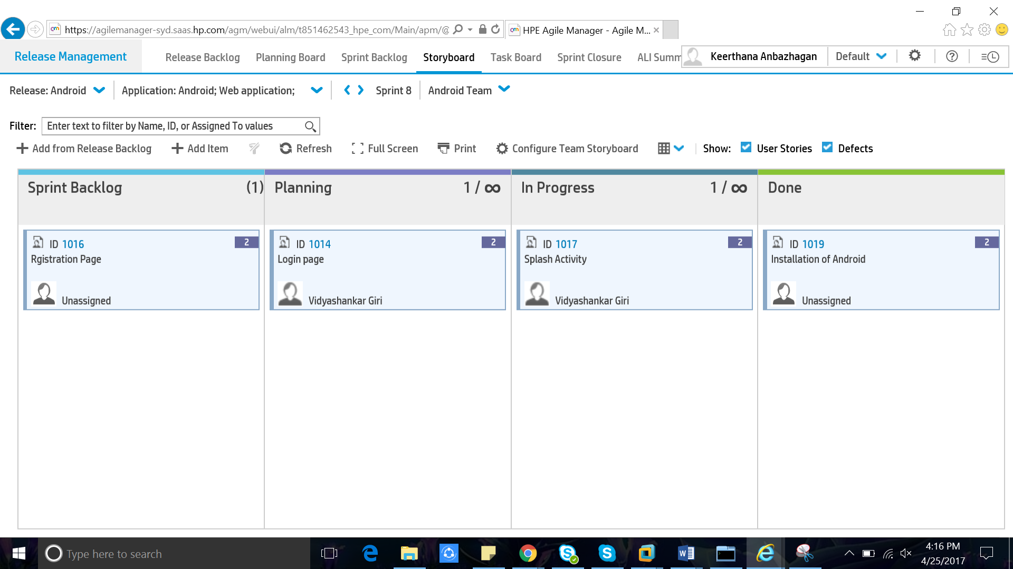

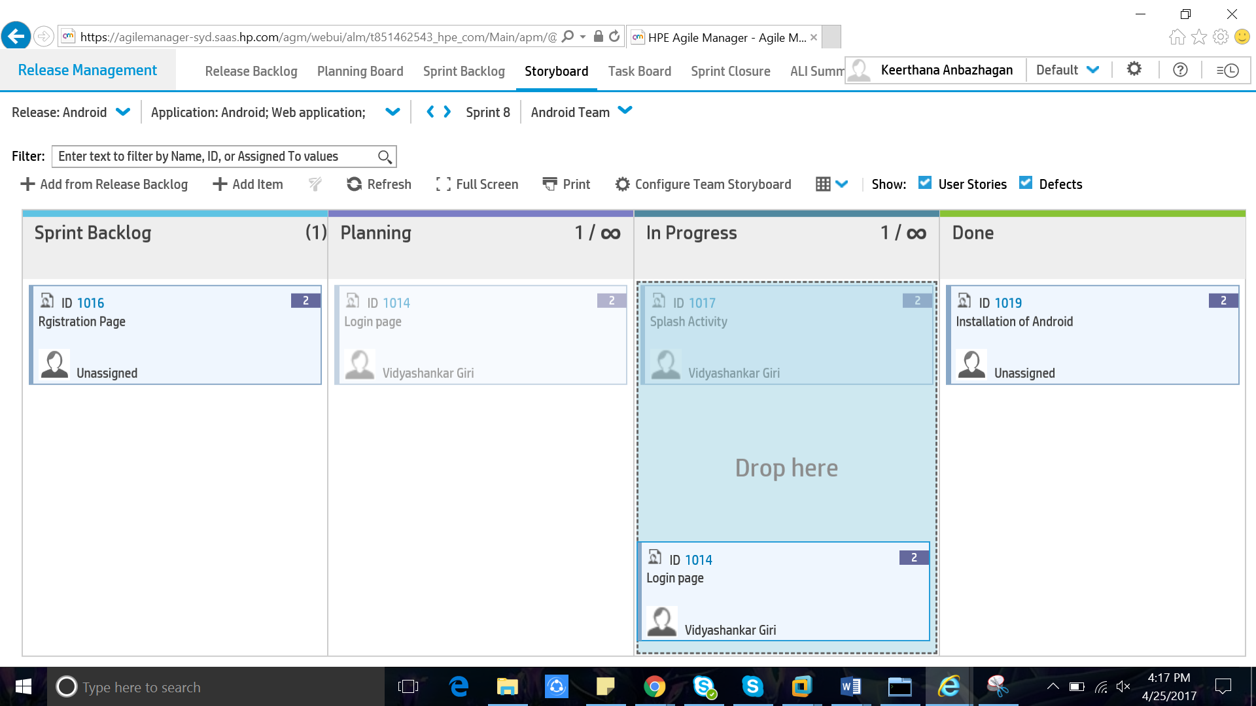

**Task board:**

Tracks the progress of sprint using a virtual task board

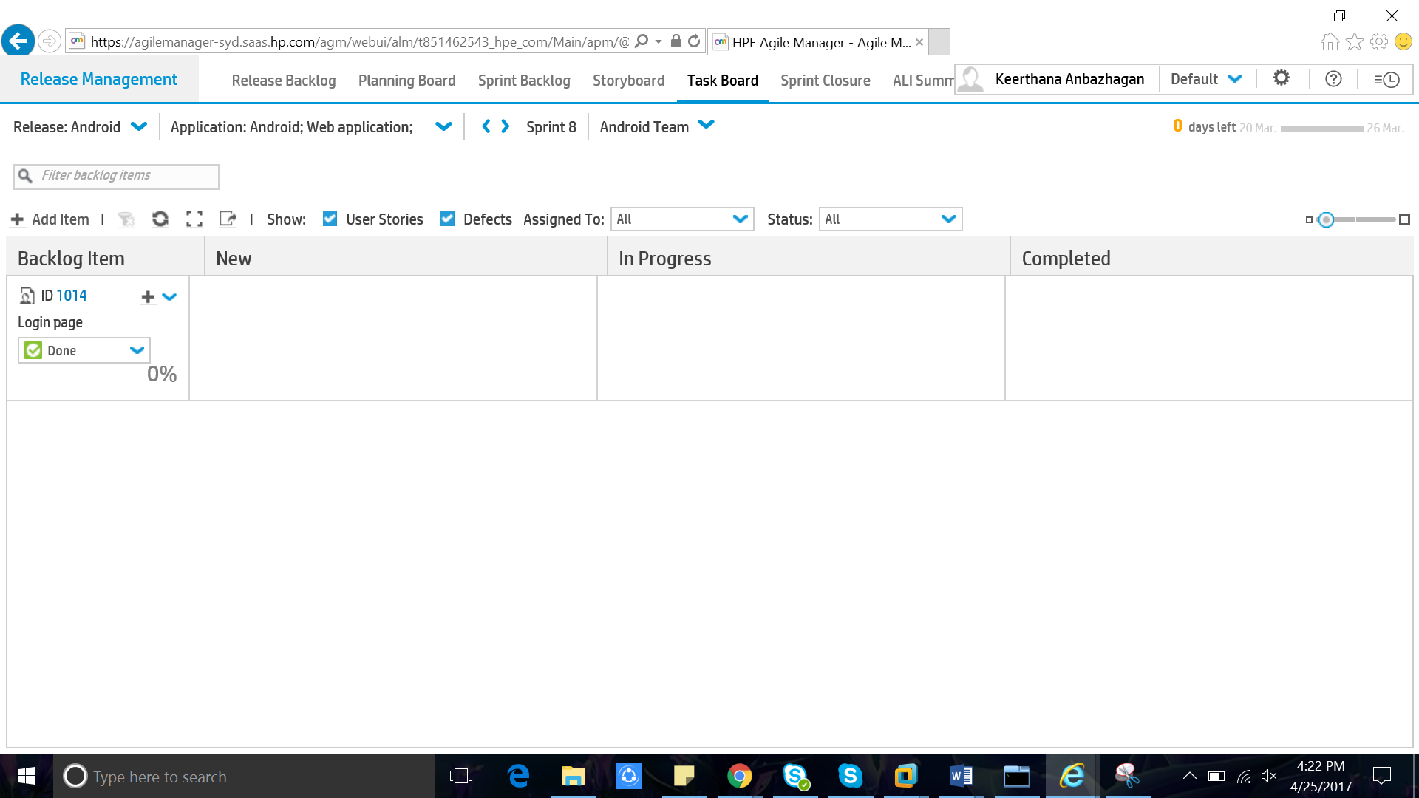

**Sprint closure:**

View a summary report of a sprint and track non-completed user stories. Write up a retrospective and use it to generate action.

**Retrospective:**

The team reflects on what happened in the iteration and identifies actions for improvement going forward. It is a practice used by team to reflect on their way of working and to continuously become better in that what they do.

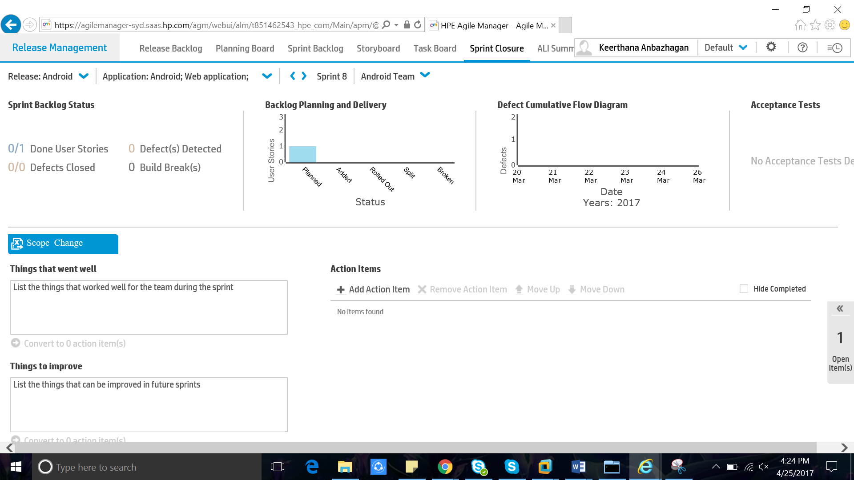

**ALI summary:**

Reviewing high-level development activity in the release, including code changes, builds, metrics and developers.

ALI – Application Lifecycle Intelligence.

It is a part of AGM which collects information from your development tools and tracks data between your plan and development.

**Defect management:**

* Report product defects
* Manage product defects
* Track product defects

**Report a new defect:**

* Click **Add Item**. The Add New Defect dialog box opens.

**Appoint a defect owner:**

1. Select defects and click **Assign To**.

2. Select a user from the user list.

**Assign defects to buckets:**

Assigning defects to buckets enables you to create categories of defects according to any criteria you

**Choose:**

1. In the buckets pane, click **Add Bucket**, and name the new bucket.
2. Select defects and drag them to the bucket. A bucket icon is displayed in the Bucket column of the assigned defects. Hover over the icon to display which buckets a defect is assigned to.
3. To display the defects in a bucket, click the bucket name

**Manage the defect life cycle:**

Manage the defect life cycle by moving the defect through its statuses. The following defect statuses are available.

**New ->** This is the status provided when the defect is first opened. Leave this status unmodified until you are ready to start work on the defect.

**Open ->** Use this status when you start to analyse or work on the defect.

**Fixed ->** Use this status when you have committed a fix for the defect.

**Closed ->** Use this status when the defect is tested and confirmed fixed.

**Propose Close ->** Use this status if you are unsure whether the defect is completely closed, or if you would like to reject the defect, and need confirmation from others.

**Deferred ->** Use this status to indicate that this defect will be fixed at a later date, and possibly not in the current release.

**Duplicate ->** Use this status to indicate that another defect exists for this same issue elsewhere in the system.

**Rejected ->** Use this status to indicate that the defect does not reflect an error in the system, and does not need to be fixed.

Defects have two statuses: the defect status and the corresponding backlog item status. These statuses are linked. When you change one status, the other status changes accordingly.

**Build and Source code:**

They are used to integrate AGM with ALM.

## Application Lifecycle Management:

## Lean, Agile and DevOps optimized ALM software and solutions help you release software faster with quality for business innovation and an amazing digital user experience.

**Key Features:**

## Flexible Delivery and Environments

Support a wide variety of tools and common standards such as SSO with SiteMinder and Common Access Card (CAC), in either [SaaS](http://www8.hp.com/us/en/software-solutions/saas-software-as-a-service/index.html) or on-premise delivery.

## Asset Sharing and Reuse

Improve efficiency, consistency, and traceability by sharing and reusing requirements and asset libraries across multiple projects.

## Cross-Project Reporting

Get the big picture and all the details with cross-project reporting and preconfigured business views that enable you to drill down into individual projects.

## Application Lifecycle Intelligence

## Make the right decisions with HP ALI providing real-time insights into who is working on what, when, where, and why. Full software development lifecycle (SDLC) traceability helps you optimize resources.

## Lab Management Automation

Speed setup of labs. Model-driven lab management helps eliminate configuration errors for more relevant and accurate results and improved quality in [enterprise agile](http://www8.hp.com/us/en/software-solutions/agile-project-management-software-development/index.html) environments.

## Requirements Management

Define, manage and track requirements through every step of the entire software development lifecycle (SDLC).